Visual Quality and Performance Notes for Textures

The Xbox™ video game system from Microsoft has a lot of memory for a console—but no matter how much memory there is, game developers always want more. Similarly, Xbox has a great deal of available memory bandwidth, but it’s quite possible to need all that and more. This makes it critical to compress large data structures as much as possible, and right at the head of the list of things to shrink is textures. Xbox offers several ways to compress textures, with varying compression levels and effects on visual quality relative to 8888 textures. The object of this paper is to familiarize you with the texture optimizations and tradeoffs available to you.
One way to compress textures is by palettizing them. Palettized textures can compress at a ratio of 4:1 losslessly for up to 256 colors per texture, but beyond that visual quality will degrade from quantization to 256 colors. Performance degradation may also result if multiple palettized textures are used simultaneously, especially if more than one palette is active at any one time, because there are only sufficient resources to decompress a maximum of eight palettized texels per clock, and those resources must be allocated between all simultaneously active palettes and palettized textures.
Another means of compression is using fewer color components. For example, a light map can be stored as an intensity texture, using only 8 bits per texel.
Compression can also be achieved by using fewer bits per texel. For example, 4444 and 565 textures require only half the memory footprint and bandwidth of 8888 textures. Because bits are lopped off color components indiscriminately, this will often not be as effective as more discriminating compression schemes such as palettization and DirectX texture compression, but because, unlike the other schemes, each texel’s color is completely independent of its neighbors, it can be useful at times.
Finally, textures can be compressed with DirectX texture compression, and it is this form of compression that this paper is primarily about. There are five distinct DirectX texture compression formats; details of these are discussed in the help for Microsoft® DirectX® 8, but for our purposes, they can be summed up quite simply, as follows.
All five DirectX texture compression formats compress texels in 4x4 blocks, and all five formats compress color in the same way (with one slight variation in the case of transparent DXT1). Two 16-bit anchor colors are specified for each block. Two additional colors are implied, one-third and two-thirds of the way (via linear interpolation) between the two anchor colors, for a total of four available colors per block. (The anchor colors are 16-bit, but the interpolated colors are calculated with 32-bit precision.) A 16-entry table contains two bits for each of the 16 texels in the block, thereby selecting one of the four colors per texel. Thus, in all DirectX texture compression formats, the net size in memory of the color alone—accounting for both the table and the anchor colors and disregarding alpha—is four bits per texel.
Alpha varies from one format to another. DXT1 supports only transparency—effectively, one-bit alpha—not translucency. Transparency can be enabled or disabled independently for each 4x4 DXT1 block. It is disabled (that is, the block consists only of opaque pixels) if the first anchor color is larger than the second anchor color; otherwise, it is enabled. If you do use transparency for a DXT1 block, only three non-transparent colors are available for that block, the anchor colors and the color halfway between them; the fourth color index is used to select the transparent color, which is always (0,0,0,0) (you can think of this as being a transparent pixel in pre-multiplied alpha form). Only DXT1 is capable of using the fourth color for transparency; the other formats always support four colors, and specify alpha separately.
DXT2 and DXT3 store four explicit bits of alpha per texel. (The documented difference between the two is that DXT2 assumes the color data has been premultiplied by alpha and DXT3 assumes it has not. However, in fact there is no difference between DXT2 and DXT3 on Xbox, and similarly, there is no difference between DXT4 and DXT5.) DXT4 and DXT5 store two 8-bit alpha anchor values and linearly interpolate six more alpha values between the anchors (much like color), and a table of 16 three-bit entries selects one of those eight alpha values for each texel.
There is effectively no size cost to DXT1 alpha (although you do lose one of the four colors). For DXT2 through DXT5, alpha costs four bits per texel. Consequently, the total size per texel—counting both color and alpha—of DXT1 is four bits; for DXT2 through DXT5, the total size per texel is eight bits.
At first mention, DirectX texture compression sounds horrible—only 4 colors for every 16; you lose up to 75 percent of your colors!—but in actual practice it works well for a great many textures. You wouldn’t want to use DirectX texture compression to, say, store a normal map—a palettized texture would probably be a much better choice there—but DirectX texture compression often works very well, and given its huge bandwidth and footprint benefits, it can and should be your workhorse texture format, especially if your artists pay attention to creating artwork that compresses well. In particular, when alpha is not an issue, DXT1 offers unmatched footprint and bandwidth benefits.
There is one additional detail to DirectX texture compression visual quality, though, and it’s an important one. Although all DirectX texture compression formats store color compressed in the same format, they do not all decompress color into the same format.
DXT2 through DXT5 decompress into 8888, thus achieving 4:1 compression. From a visual quality perspective, this is ideal. However, decompression takes place as texels are stored into the texture cache, so DXT2-5 formats take up a lot of space in the texture cache—and since the texture cache is only 8 KB, space is at a premium.
DXT1, in contrast, had been implemented in such a way that it decompresses into 1555. (You might think it would be 565 unless there’s alpha, but because all blocks have to have the same format in the texture cache and because alpha can be selected on a block-by-block basis in DXT1, the decompressed-to texture format has to have alpha in it.) Like the other DirectX texture compression formats, this achieves 4:1 compression. (The compression is actually 8:1 relative to 8888, but since the decompressed result is in fact 1555, not 8888, that doesn’t seem like an appropriate standard of comparison to me—but think of it as 8:1 if you wish; the results are the same either way.) However, both the compressed and uncompressed formats are half the size of those for the other DirectX texture compression formats. In terms of memory footprint, texture footprint, and bandwidth, this is ideal.
Unfortunately, 16-bit decompression of DXT1 is not ideal in terms of visual quality, sometimes resulting in visible banding and other artifacts. This is noticeable enough with currently shipping NVIDIA hardware that it was written up in the press. While it by no means makes DXT1 unusable, it does decrease the number of textures for which DXT1 is appropriate. Fortunately, this problem is partly fixed in the Xbox GPU. (Note that the fix is not in the Alpha-2 XDK.)
The Xbox DXT1 fix works as follows. On the Xbox GPU, if the render target is 16-bpp, then DXT1 is, as you’d expect, decompressed to 16-bit texels in the texture cache. With a 32-bpp render target, DXT1 textures are still decompressed to 16-bit format, but as textures are decompressed, an encoding/decoding technique is employed to add a subtle amount of noise and thereby minimize 16-bit artifacts. This isn’t a perfect solution; because it happens in texture space, not screen space, aliasing can happen when textures are minified, and the noise can become visible when textures are magnified. Nonetheless, it helps considerably in many cases. Consider the following.

First, here’s a 24-bpp texture with subtle gradients:


Next, here’s the same image compressed with DXT1 (using the S3TC tool) and decompressed to 16 bits/pixel:

Banding is readily apparent.
Finally, here’s the same image compressed with DXT1 and then decompressed with the Xbox DXT1 noise fix:

Note that the banding is completely eliminated.
Similarly, here’s a 24-bit texture:


and here’s the same texture after DXT1 compression and subsequent decompression with the Xbox fix:


As you can see, the DXT1 fix can help a great deal. Of course, some of the effects of the noise will be visible only when triangles tilt and move, but the results of tests thus far are promising, with few artifacts even for moving surfaces. If you’d like to see the effect of the DXT1 fix on a few of your textures, you can send them as 24-bit .tga files to xboxds@xbox.com, and we will DXT1-compress them, decompress to 16-bit textures using the noise fix, and send them back to you.

The fix doesn’t help in all cases; there are some instances in which the noise becomes visible. The noise artifacts are not very noticeable in most of these cases, but there are exceptions. For example, over large areas of nearly-constant color, the added noise may be more visible than you would like. Also, the noise artifacts can become quite noticeable when 3-D textures are sampled along a slice of constant u or v, because the noise is added based only on u and v, not p (the third scaled texture coordinate). For example, consider the following constant-v slice through a 24-bit 3-D texture:
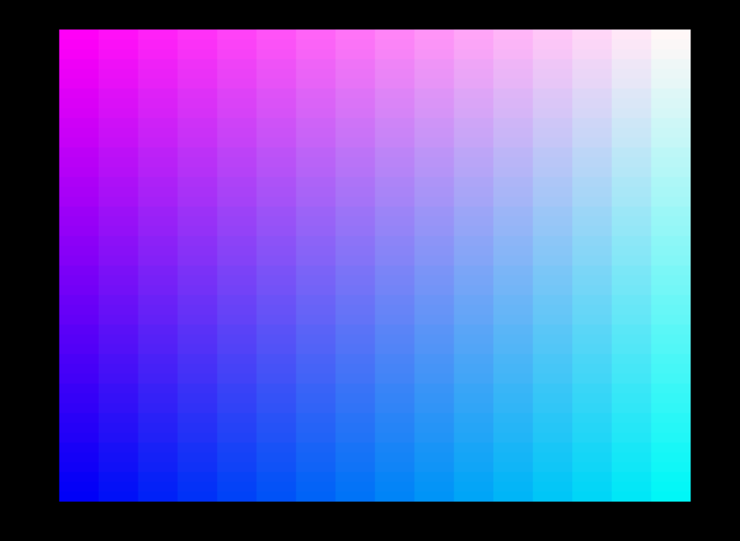

After DXT1 compression and decompression with the Xbox noise fix, the added noise produces visible artifacts:


Fortunately, it is possible to disable the noise and get straight 16-bit decompression whenever that’s preferable, as would likely be the case here. However, note that each time noise is enabled or disabled, the graphics pipeline flushes (not the whole push-buffer, just what’s in the hardware pipeline), so this is not something you’d want to do too frequently. This only happens with a 32-bit render target, of course.

Overall, although the fix doesn’t always help, it should help DXT1 be more broadly useful than it would be otherwise. Consider the following 24-bit test pattern:
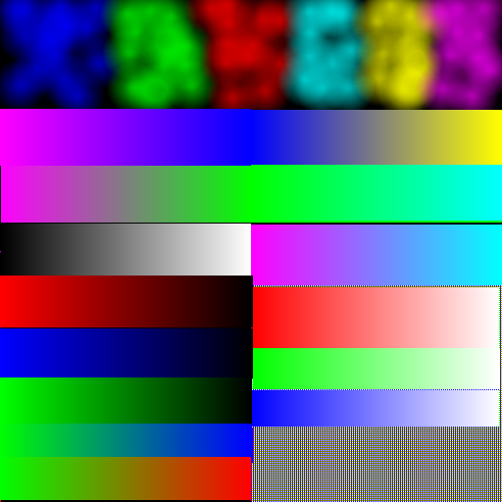

Here’s the same test pattern after DXT1 compression and decompression with the fix:
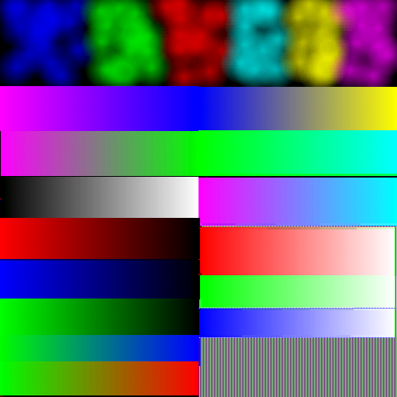
The part of the test pattern at the lower right is not reproduced correctly (DirectX texture compression has a hard time with very high-frequency texture components), but the rest of the image has been preserved remarkably well.
Note that all of the above textures are available for download (Images.zip, on BetaPlace) if you want to experiment with them.
Of course, no hardware with this fix exists yet, so we’ll have to wait to see exactly how well it works across a broad range of textures—but the bottom line is that DXT1 will be pretty broadly usable on Xbox, and should be the first option to try for non-alpha textures, with DXT2-5 and palettized textures as the next best choices, and uncompressed textures (possibly with a reduced number of color components or bits per color) as the ultimate fallback.
It is true that while the DXT1 fix will help, it would have been ideal to have additionally given the programmer the option to decompress DXT1 to 32-bit texels if desired; this would have resulted in substantially better visual quality for some textures, making DXT1 even more widely usable. Any of the other DirectX texture compression formats can of course be used to get 32-bit texels, but because those formats are twice as big as DXT1, they impose a considerable memory footprint and bandwidth cost relative to DXT1 (although still very attractive compared to uncompressed textures). So it would certainly have been nice if the 32-bit DXT1 option had been available—but it isn’t, so we’ll just have to work with what we have, which shouldn’t be too bad with the addition of the 16-bit noise fix.

